For Immediate Release
Tuesday, January 26, 2016

For Further Information:
Call Mike Lynskey at 312-440-9191
Mike.Lynskey@jamusa.com

“Seeing Peppa up close in an interactive format will awe your pint-sized fan in a whole new way…A preschooler’s dream come true.” -Mommy Poppins

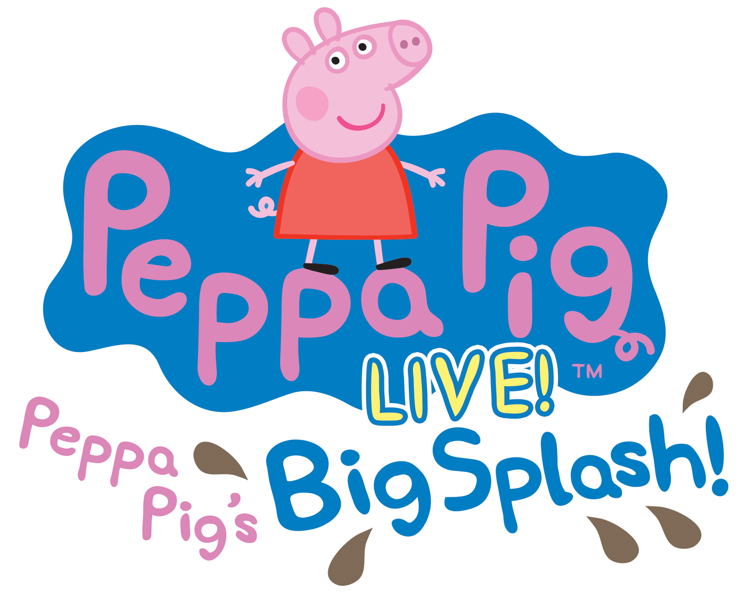

Peppa Pig Live! Makes Big Splash with Fans as
U.S. Tour Prepares for Second Leg

50 Sold Out Shows and 150,000 Tickets Sold to Date

Peppa Pig’s Big Splash Visits Minneapolis on Saturday, March 19 for 1 Show

Minneapolis, MN, January 16, 2016 – More fun than a muddy puddle! Peppa Pig, star of Entertainment One’s (eOne) top-rated TV series, airing daily on Nick Jr., has made a huge splash with her first U.S. tour! Peppa Pig’s Big Splash (www.peppapigliveus.com) added 65 cities and 100 performances last September due to strong ticket sales and popular demand. To date, 150,000 tickets have been sold, with multiple sell-outs across the country. The second leg of the tour resumes January 16 and will visit Northrop at The University of Minnesota on Saturday, March 19.

Reserved seat tickets ($46/$41/$36/$31) plus VIP packages are available at the Northrop Box Office, online at northrop.umn.edu or by phone 612-624-2345.

“Peppa Pig is every bit the superstar we imagined she would be on tour here in the U.S.,” said Jonathan Shank, Red Light Management, a producer of Peppa Pig’s Big Splash. “With 22 of the first 27 shows sold out, and many more performances being added for 2016, Peppa Pig Live! will continue to be the hottest ticket for families.”

With even more tour dates to be announced, 2016 is shaping up to be a banner year for Peppa Pig. “The Golden Boots”, a brand new 15-minute TV special, will air on Nick Jr. in March with an app, DVD and digital download timed to coincide with the on-air premiere.

Peppa Pig’s Big Splash, based on the hit Peppa Pig TV series, is an action-packed live show designed to deliver to preschoolers and young fans an unforgettable first live theater experience. A fully immersive musical production featuring a dozen familiar and original songs, as well as an interactive sing-a-long, the live stage show will have fans laughing, singing, dancing and, of course, jumping in muddy puddles – just like Peppa!

In Peppa Pig’s Big Splash, the nursery roof is leaking and Peppa and her friends need to fix it quickly. They set up a fair to raise money so Mr. Bull can do the repairs. There’s plenty of fun to be had as Peppa, George, Mummy and Daddy Pig, along with Danny Dog, Pedro Pony and Suzy Sheep, work together to organize an exciting day out complete with a Champion Puddle Jumping competition judged by Mr. Potato, where everyone gets wet! An interactive experience full of singing, dancing, games, and muddy puddles, Peppa Pig’s Big Splash is a guaranteed blast for preschoolers and their parents alike.

For more information about Peppa Pig, please visit www.peppapigliveus.com, Facebook and Twitter.

Show credits:
- Director - Richard Lewis
- Composer - Mani Svavarsson
- Lyricist - Matt Lewis
- Designer - Simon Scullion
- Music Director - Andy Booth
- Produced by Red Light Management, Fiery Angel and eOne

Media Contacts:

John Tellem (for Peppa Pig Live)
Tellem Grody PR
310-313-3444 x2
john@tellemgrodypr.com

About Entertainment One
Entertainment One Ltd. (LSE:ETO) is a leading international entertainment company that specializes in the acquisition, production and distribution of film and television content. The company’s comprehensive network extends around the globe including Canada, the U.S., the UK, Ireland, Spain, Benelux, France, Germany, Scandinavia, Australia, New Zealand and South Africa. Through established Film and Television divisions, the company provides extensive expertise in film distribution, television and music production, family programming, merchandising and licensing, and digital content. Its current rights library is exploited across all media formats and includes more than 40,000 film and television titles, 4,500 hours of television programming and 45,000 music tracks

Brought to you by Jam & Northrop
###

