MAKING A MURDERER’S DEAN STRANG & JERRY BUTING:
A CONVERSATION ON JUSTICE
NORTH AMERICAN DATES ANNOUNCED
TICKET PRESALE THURSDAY MARCH 3, ONSALE FRIDAY MARCH 4

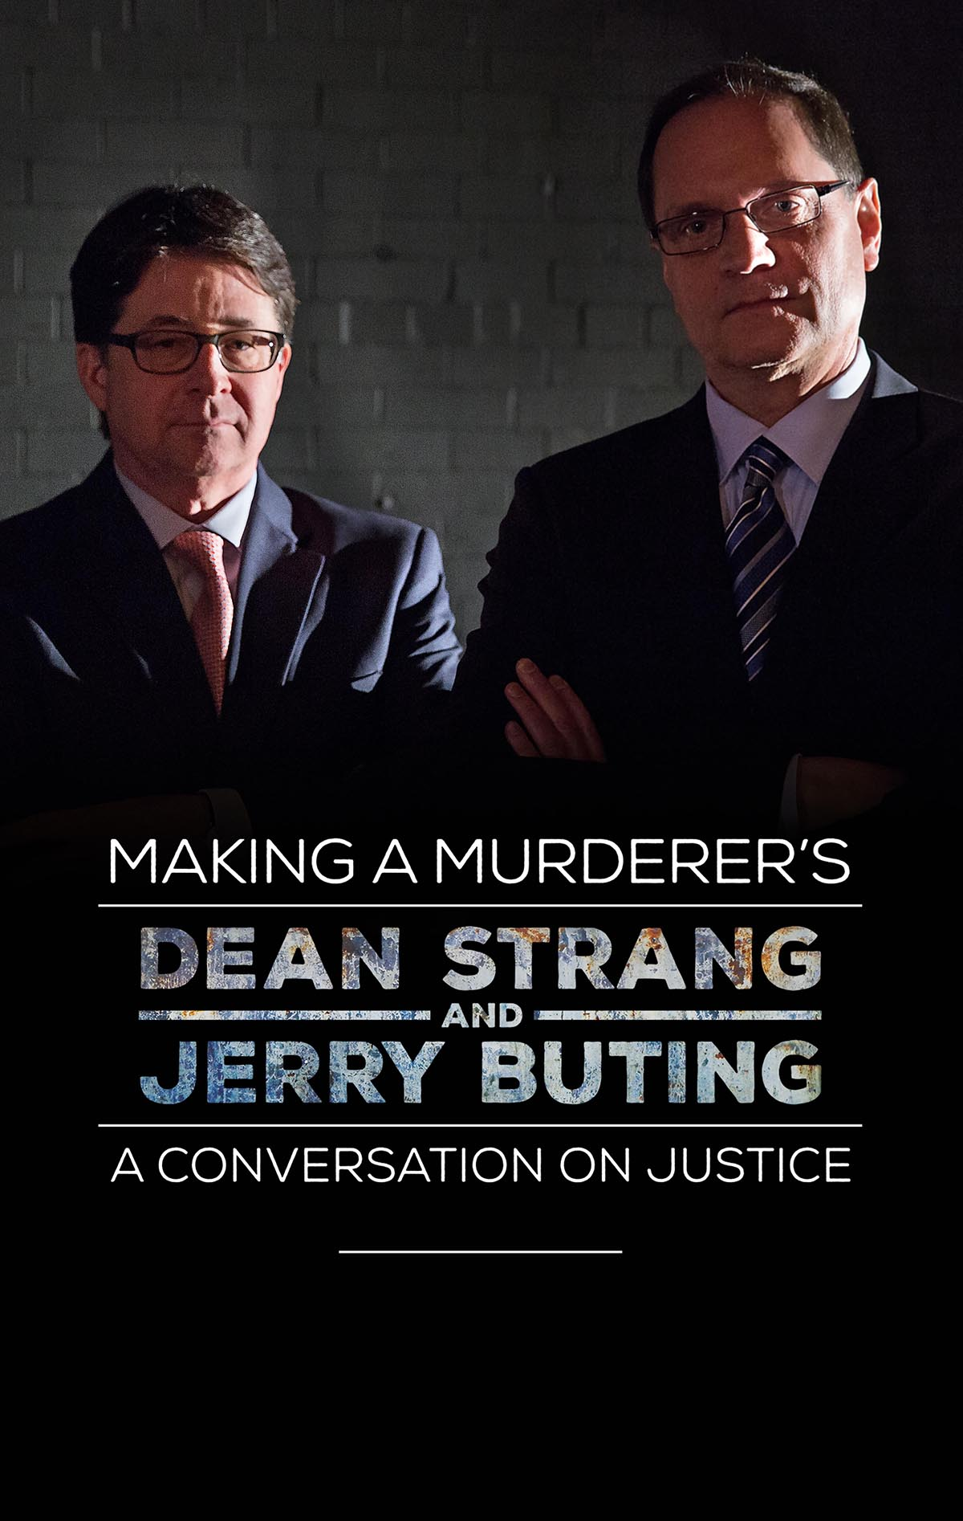

Dean Strang and Jerry Buting, defense attorneys for Steven Avery in the Netflix documentary series Making A Murderer, announce North American dates for A Conversation on Justice Tour. Strang and Buting’s multi-city speaking tour, which starts April 16th at Berklee Theater in Boston and hits cities across the U.S. and Canada through mid-August, will involve the two attorneys in conversation about the Steven Avery case and its broader implications, as well as a discussion on the larger topic of the American criminal justice system. Each night will also feature a Q&A portion and the opportunity for the audience to address questions directly to Dean Strang and Jerry Buting.

At a time when the nation is gripped with pressing questions about the fairness and effectiveness of our criminal justice system, concerns that have been highlighted by true crime narratives from Making A Murderer, Serial and The Jinx to the murder trial of O.J. Simpson, Strang and Buting will be exploring and discussing our process of justice today and throughout history. Reviewing these situations, they will highlight the imperfections in our judicial system and suggest improvements that are sorely needed.

Local ticket pre-sale begins Thursday, March 3 at 10am local time, general onsale begins Friday, March 4 at 12 noon local time. More at: ConversationonJustice.com

DEAN STRANG & JERRY BUTING:
A CONVERSATION ON JUSTICE TOUR
4/16 – Boston, MA @ Berklee Performance Center
4/17 – NYC @ Beacon Theatre
4/24 – LA, CA @ The Theatre at Ace Hotel
4/30 – Columbus, OH @ Palace Theatre
5/1 – Cincinnati, OH @ Aronoff Center – Procter & Gamble Hall
5/20 – Durham, NC @ Durham Performing Arts Center
5/21 – Houston, TX @ Cullen Performance Hall
5/22 – Dallas, TX @ Majestic Theatre
6/2 – Minneapolis, MN @ Northrop
6/3 – Chicago, IL @ The Chicago Theatre presented by Chase
6/10 – Cleveland, OH @ Playhouse Square - State Theater
6/11 – Toronto, ON @ Sony Centre for the Performing Arts
6/12 – Atlanta, GA @ Cobb Energy Performing Arts Center
6/17 – Seattle, WA @ Paramount Theatre
6/18 – San Francisco. CA @ The Warfield Theatre
6/19 – Portland, OR @ Arlene Schnitzer Concert Hall
7/15 – Kansas City, MO @ Arvest Bank Theatre at the Midland
7/16 – Denver, CO @ Paramount Theatre
7/17 – San Diego, CA @ The Balboa Theatre
7/29 – Vancouver, BC @ Orpheum Theater
7/30 – Calgary, AB @ Southern Alberta Jubilee Auditorium
7/31 – Edmonton, AB @ Northern Alberta Jubilee Auditorium
8/12 – Phoenix, AZ @ Celebrity Theatre
8/13 – Austin, TX @ Paramount Theatre
8/14 – Nashville, TN @ TPAC’s Andrew Jackson Hall
8/20 – Clearwater, FL @ Ruth Eckerd Hall
8/21 – Ft Lauderdale, FL @ Broward Center for the Performing Arts

Watch: A Conversation on Justice Tour Trailer: https://youtu.be/uF8o_5vloZc

Find more info at: ConversationonJustice.com
Follow the tour on Twitter, Facebook and Instagram @strangandbuting

Media Requests to Sheila Kenny at Right On! PR
e. sheila@rightonpr.com // c. 917-847-9977

